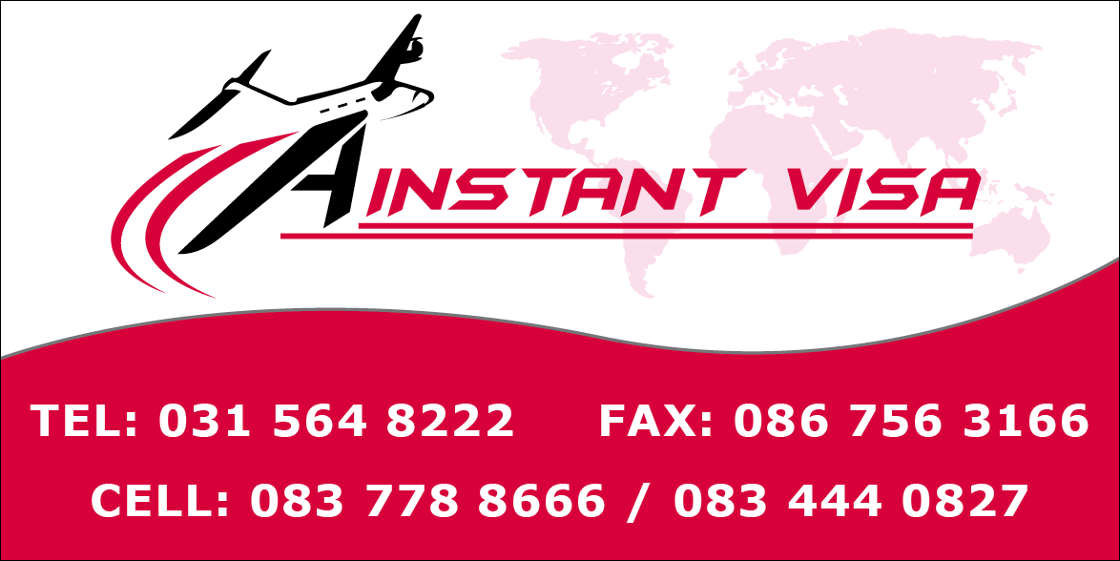

DOCUMENTS REQUIRED
SHORT STAY VISAS (BUSINESS/TOURISM/VISITING FAMILY AND FRIENDS)
REQUIREMENTS FOR A VISA
Submission checklist:
- PLEASE ENSURE YOU MAKE COPIES OF ALL SUPPORTING DOCUMENTATION.
- Valid passport for at least 3 months after leaving Schengen states with at least 3 empty pages
- Nationals with Dual Nationality (EU passports and SA passports) are not allowed to apply for visas.
- Schengen Visa form completed in full.
- Travel insurance (if ticket not paid with credit card), if paid with credit Card copy of first pages of policy showing cover. Visa Letter
- Travel allowance - Photocopy of receipt of purchase of traveller’s cheques or latest credit card statement (Up to date Three months Bank Statements stamped from the bank)
- Flight Reservations indicating booking reference number + photocopy. Please note: For non-South African citizens we will accept a reservation to process the visa.
- Proof of employment (3 month pay slip, employment letter) – if self-employed a letter from bookkeeper stating nature of business.
- Proof of accommodation – Hotel booking or Term of responsibility (Form available on website ), authenticated at the Notary Offices in Portugal or if the invitation is done by a person in South Africa, signature authenticated by a local commissioner of oaths. Applicant requires to keep the Original of the Term of Responsibility as this is required for Travel.

- Children (up to 18 years old) travelling alone or with a family member need authorization by both parents authenticated by a Commissioner of Oaths or Police, giving permission for the child to travel. At the same time letter/Term of responsibility from family members in Portugal.
- All children travelling need proof of Full Birth Certificate or the official documents/court decisions establishing the minor’s parents/legal guardians. Only in case of delay by SA authorities to issue unabridged birth certificate: proof of having lodged the relevant request to the competent authorities (home affairs) showing the parents names and stamped by Home Affairs
- Spouses of EU/EEA citizens (EEA: Norway, Iceland, Lichtenstein) and their children, under the age 18 must present original of spouses’ EU/EEA passport, Full Marriage/Full Birth certificates as proof of relationship. There is no need for insurance or travel allowance, and visa will be free of charge. THIS ONLY APPLIES IF EU/EEA CITIZEN IS ALSO TRAVELLING.
- Spouses of EU/EEA citizens (EEA: Norway, Iceland, Lichtenstein) and their children, under the age 18 must present original of spouses’ EU/EEA passport, Full Marriage/Full Birth certificates as proof of relationship. There is no need for insurance or travel allowance, and visa will be free of charge when above documents duly submitted and are not subjected to travel with the spouse that holds the EU passport
APPLICANT CAN BE REQUESTED TO COME FOR AN INTERVIEW AT ANY TIME.
Spouses and children under 21 of EU nationals
Application form
Application form. EU decent need to provide residence details for travel to Portugal and same details must be completed on the application form.
1 recent colour photo
Airline ticket
Marriage certificate for spouse and unabridged birth certificate for children
Copy of a valid EU passport of the spouse or parent
All children under 12 do not do biometrics
In addition to the above below documents are also required.
List of supporting documents to be submitted by applicants for short stay visas in South Africa
- GENERAL REQUIREMENTS for applicants:
  - Duly completed, dated and signed “Application Form”, (available free of charges from consular websites, or consular offices.).
  - Passport, which must be valid for a period of at least 3 months after the applicant’s last day of stay in the Schengen states and not older than 10 years. The passport must have 3 blank pages to affix visa. Holders of the temporary SA passports must enquire whether or not the countries of transit and destination recognize this type of travel document.
  - One recent passport sized photograph in color.
  - If traveling via the Schengen area to a third country, the visa of the final country of destination must be obtained before applying for a Schengen visa.
  - Proof of payment of the visa fee, unless waived according to the provisions of the Visa Code.
  - Travel/health/accident insurance stating that the applicant is covered by a Schengen
Travel Medical Insurance, i.e. minimum medical coverage of the Rand equivalent of Euro
30.000 for all medical expenses, including repatriation dead or alive, occurring in any Schengen country.
- Supporting documents for ALL APPLICANTS:
  - Round trip reservation or itinerary with dates and flight numbers specifying entry and exit from the Schengen area.
  - An invitation from the host or a company in a Schengen state. For participation in conferences: a proof of registration and payment. For official visits, a note verbale from the Department of International Relations and Cooperation is required.
  - Proof of accommodation for the whole duration of the intended stay. Confirmed hotel reservation is requested (hotel vouchers are not necessarily proof of confirmed hotel booking). If applicant is staying with a relative or friend, the relevant authorities may request invitation letter from the host with copy of his passport or ID. This invitation maybe requested in a specific format (Term of Responsibility), and authentication by the relevant authorities may be required. In case of a pre-paid tour, details of the tour with a proof of payment to the tour operator must be provided.
  - Proof of sufficient means of subsistence during the intended stay (Up to date three months Bank statements stamped from the bank).
  - Proof of employment: a letter from company stating monthly wages, continuing employment after period of leave and duration of vacation etc. In the case of self-employment a certification from SA Companies and Intellectual Property Commission or SA Revenue Service is required.
- Documents to be provided for CHILDREN under 18 years of age:
  - Full (unabridged) birth certificate.
  - If the child is traveling alone: certified parental consent by both parents.
  - Certified copies of ID/passport of both parents.
  - If the child travels with only one parent, the other parent must produce the certified consent. If only one parent has guardianship of the minor, the relevant court documents must be presented.
  - Child under 6 years the Visa is Free of charge
  - Child between ages 6 – 12 Visa fee is half
- Documents to be provided by STUDENTS:
  - Letter from school/college/university confirming attendance.
- Documents to be provided by NON-SOUTH AFRICAN nationals:
  - Evidence of a legal stay or a residence permit in South Africa valid for a period of at least 3 months after the applicant’s last day of stay in the Schengen states.

