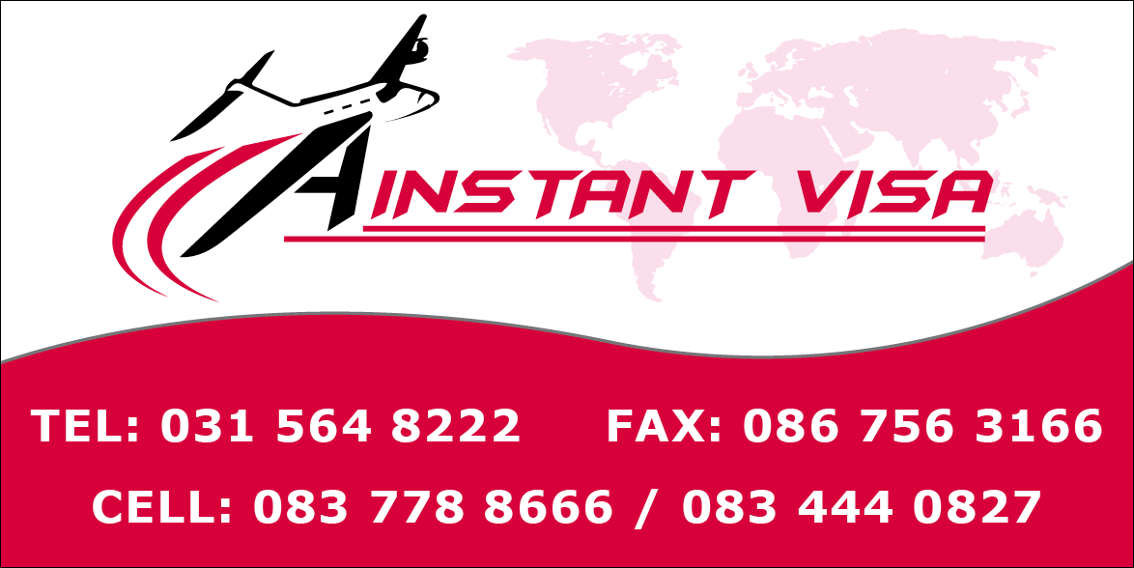
French Requirements

Passport
Must be valid for at least 3 months after the date of return from your trip and not older than 10 years. At least 2 valid blank pages (marked VISA). Passport need to be in good shape.
Copy of the ID page and of all previous Schengen Visas in last 4 years. South African Temporary passports will not be accepted.
For non S.A passport,
Original and Copy of valid S.A permit stapled with copy of the ID page of the passport (permit must be valid for at least 3 months after the date of return from your trip).
Schengen Application Form
All fields required properly filled out. Form must be signed by applicant (3 signatures per form). In case of minors form must be signed by the 2 parents. If you are stating "No Occupation" at the point 19, please add to your file an explanatory letter of your current situation.
Color ID Photos
2 Color ID photos as required by Schengen Standards.
Travel Insurance (SS)
1 page travel insurance policy certificate to be provided, which shows: name of insured person; policy number; amount of cover which should be for at least € 30,000; duration of cover which should be for the entire holiday period whilst traveller will be overseas; the insurance should cover the entire Schengen territory, therefore the term Schengen should appear on the policy certificate. Also the term repatriation should appear.
All persons traveling in CTOM-DOM must provide insurance to be covered in these territories (this is therefore not a Schengen insurance. Coverage must mention Worldwide or the country of destination).

Proof of Accommodation (SS)
All hotel/apartment rental/lodge/chalet/château confirmed bookings for the entire period that the person will be in the Schengen area must be provided. The name of the applicant must appear on the accommodation bookings. If not, Proof of Accommodation Form (Downloadable from Capago Website) must be provided and attached with the ID of the person who made the booking. If applicant will visit French citizen or temporary resident in France, the original attestation d'accueil and a copy must be provided. This official document will be obtained by your host from the town hall in France. Your host must courier the original document to you in South Africa, before you apply.
If applicant is invited by someone who owns home/property in France but is not resident in France, the title deeds of that property and a letter of invitation must be provided. If applicant owns a home/property in France, the title deeds of the property must be provided.
Proof of Transport (SS)
Round Trip flight ticket from South Africa to France must be provided. All transfers (flight/ferry/train/bus/taxi) showing entry & exit from France and between other countries must be provided. Name of applicant must appear on all proof of transport. All confirmed car rental bookings must equally be provided.
If the applicant is being collected by EU resident abroad, a copy of the EU’s driver's licence, car registration details and a short letter of confirmation of pick-up and drop-off details will be necessary.
Proof of Funds
Please provide the latest 2 months personal bank statements or latest 2 months credit card statements showing the amount available in the account. Please note that name of the applicant must appear on the bank statement. Please note that bank statements need to be stamped by the bank If the applicant is being sponsored, please provide the latest 2 months bank statements of the sponsor and a letter from sponsor attesting to the fact that they will sponsor the applicant on their trip abroad. Please note that even if the applicant is being sponsored, applicant's personal bank statements need to be provided.
If the bank statements are in the name of a company or a trust, then the applicant must provide company registration documents or trust documents showing that they are a member of the company or the trust. Please note that all bank statements in Afrikaans must be accompanied by a signed and stamped visa letter from the bank on bank letterhead, in English, confirming the account holder has enough funds to travel.

Proof of Employment
Original letter of employment, issued in the 2 last months, on company letterhead, signed by a manager, showing that the applicant is currently employed by the company and indicating the monthly salary. This letter MUST be an ORIGINAL. No scanned copy will be accepted.
If an applicant owns their own company then they must provide the company registration documents CC or CK documents on which applicant's name appears.
If the applicant operates as a sole trader then they must provide a written affidavit declaration to this effect with any other official document related to the business.
If you are retired, please provide a copy of your retirement card (SASSA card) or a document related to your pension fund or a certificate (excluding affidavit) indicating your status as a pensioner.
Letter from School / University / College (if applicable)
A signed & stamped letter on letterhead declaring that applicant is still a pupil/student currently registered at the
School/University/College.
This letter MUST be an ORIGINAL. No scanned copy will be accepted.

Unabridged Birth Certificate
Applicants must provide a copy and the original. It must show names of both parents and name of child.

Parental Consent Letter
1. Both parents of the minor should present themselves at our offices to sign the parental authorization letter in the presence of designated Capago officers.
If for any reason one of the parents cannot be present at Capago, he/she must provide an affidavit stamped by a Commissioner of Oath giving reasons of absence, granting permission for the minor to travel (stipulate dates of travel) and specify who will accompany the minor on the trip.
2. The copy of parent’s passports or a copy of a signed Driver's License must be included together with the parental authorization/consent.

